Jenkins day 4

1) Setup jenkins CICD pipeline using freestyle job using below code.

https://github.com/betawins/hiring-app.git

Stages:

1) Git Clone

2) Sonarqube Integration

3) Maven Compilation

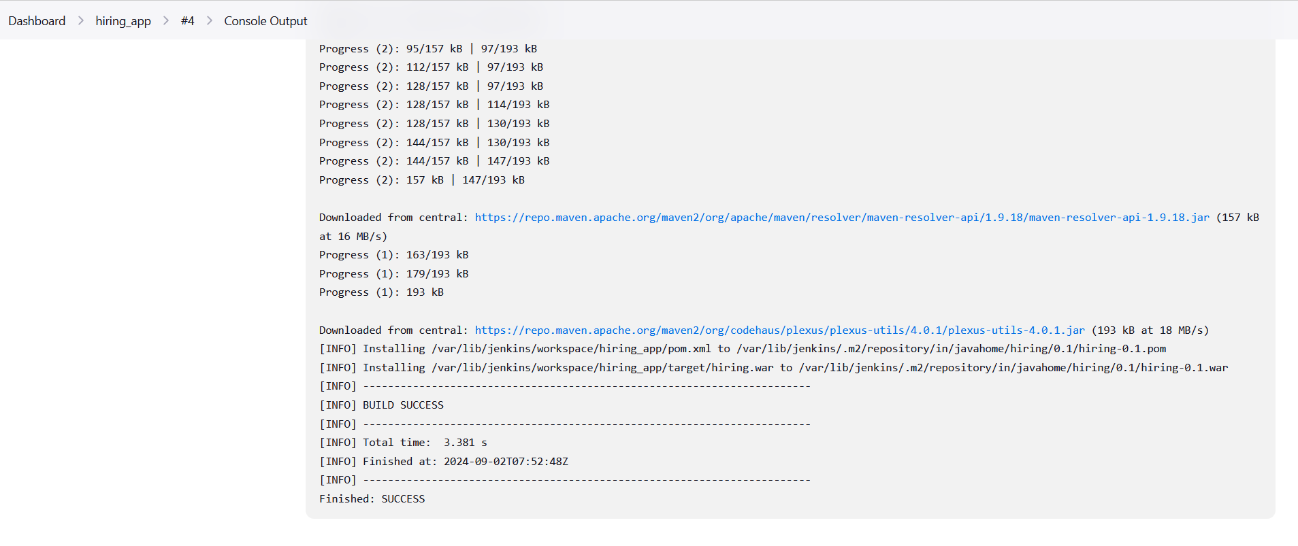

Created war file

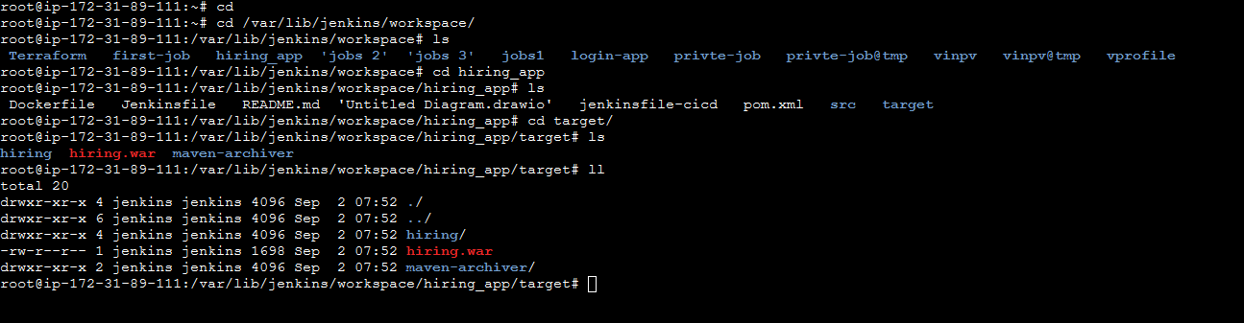

4) Nexus Artifactory

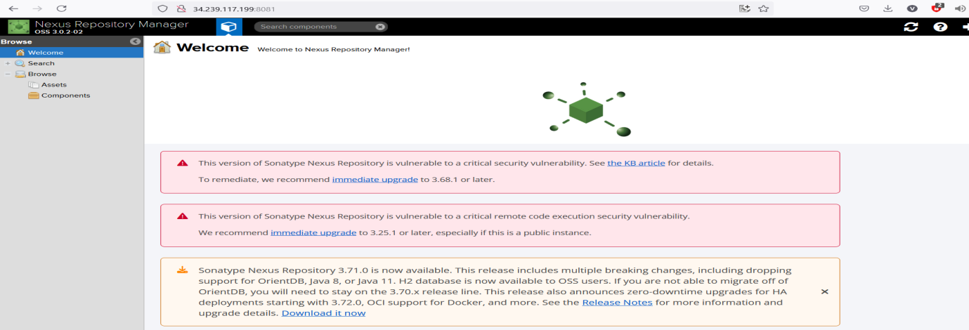

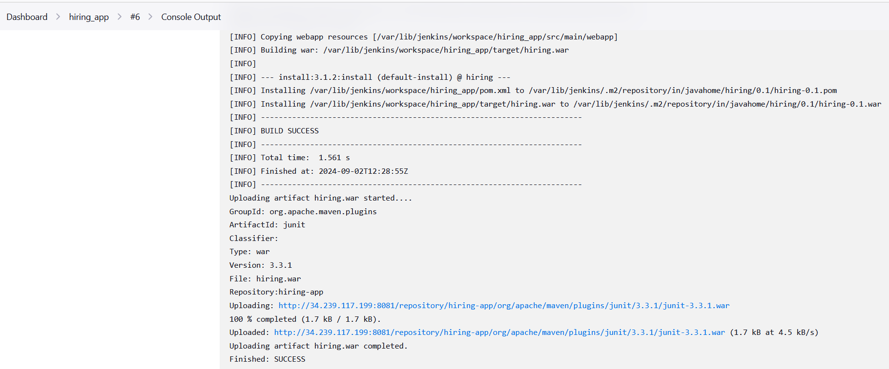

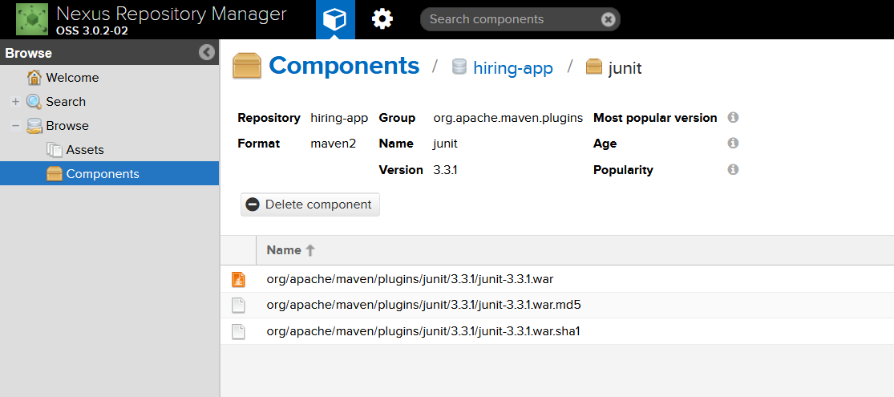

5) Slack Notification



6) Deploy On tomcat

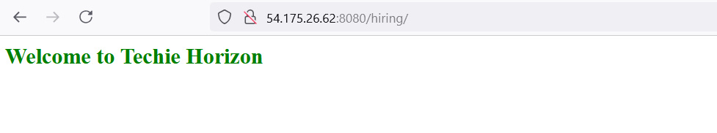

2) Setup jenkins job using freestyle job using below code.

https://github.com/betawins/Techie_horizon_Login_app.git

Stages:

1) Git Clone

2) Sonarqube Integration

3) Maven Compilation

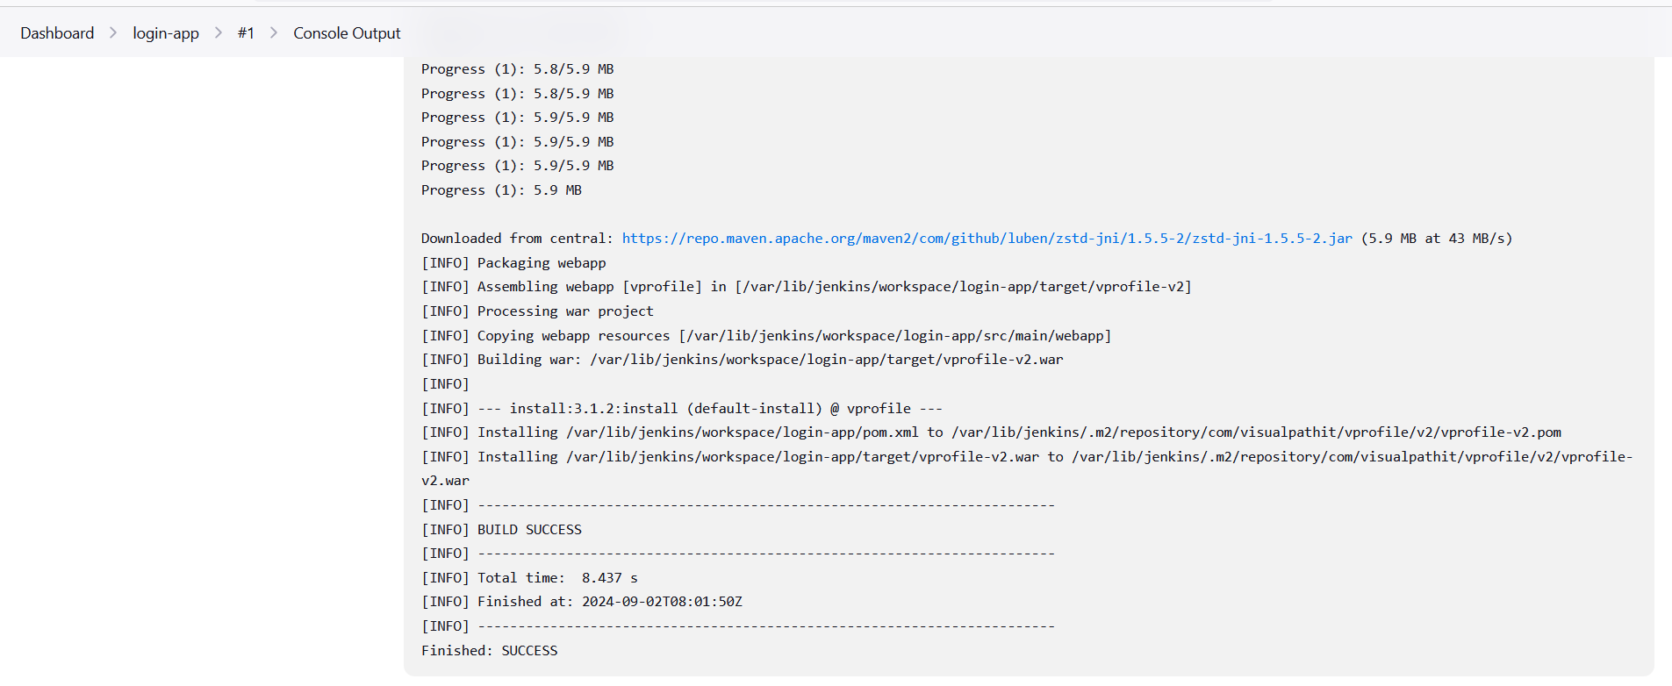

Created war file

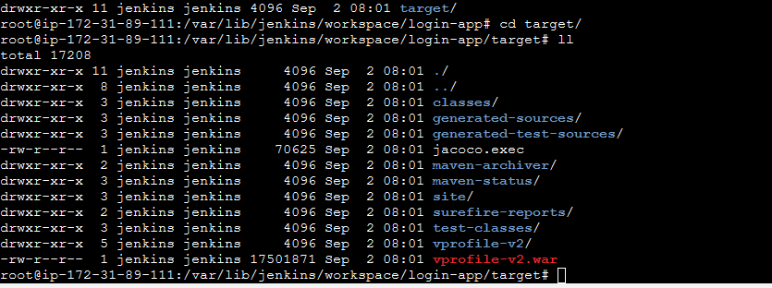

4) Nexus Artifactory

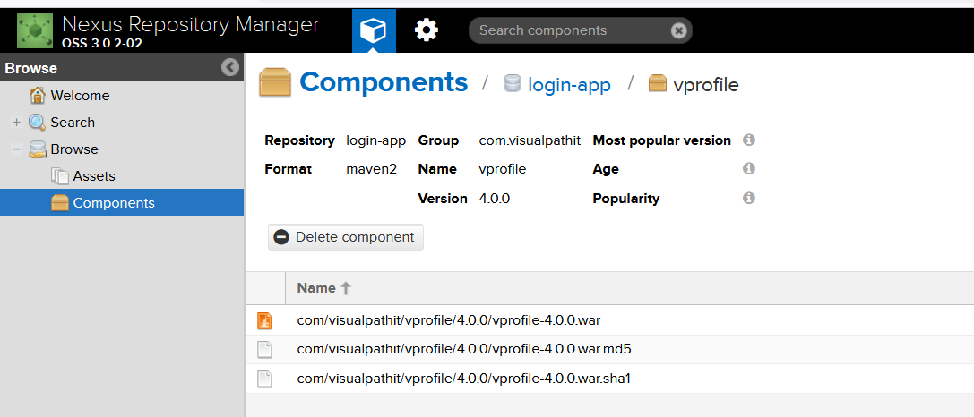

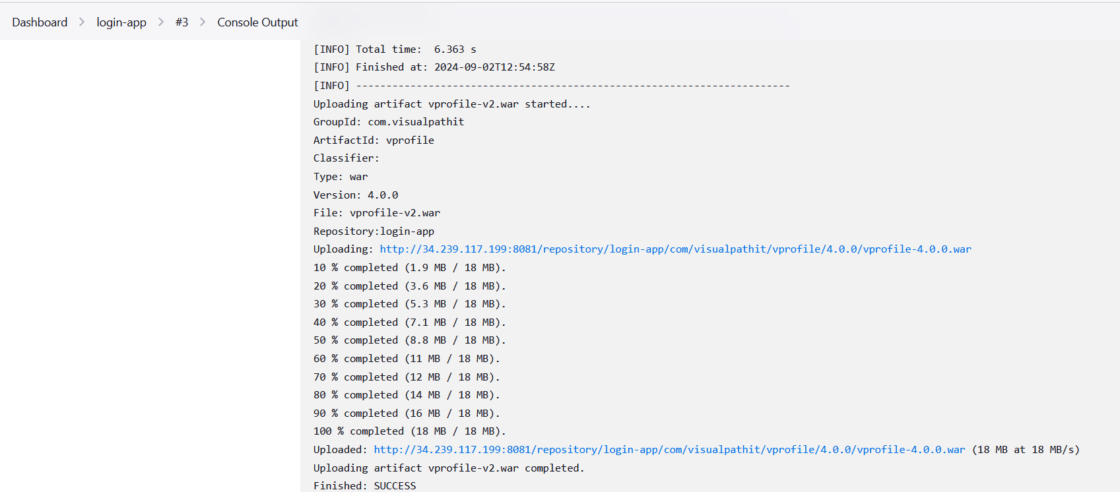

5) Slack Notification



6) Deploy On tomcat

